Student Speak Newsletter
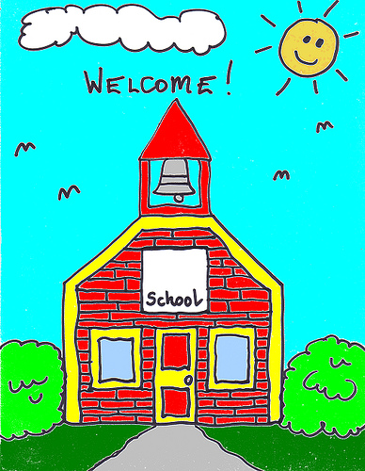


May 2012 - Articles by Room 12 Students

Acceptance  By Mark, Armaan, Megan  May is here! Courtesy is everywhere throughout Westvale. Our class read a book called Library Lion. The main idea of the book was to show courtesy in places like the library. At our assemply, they showed pictures of people doing courteous things. Our school loved it! One good quote about courtesy is that ‘we win with class and lose with dignity’. Westvale is very courteous. KEEP BEING COURTEOUS WESTVALE!    Jump Rope for Heart  By Sasha, Arlinda and Cassidy  On In the month of May, our school participated in the annual Jump Rope for Heart. Last year, we raised almost $4000, enough to buy a heart transplant station! This year, for our jump day, there were different stations like limbo, group jumping and even a freezie station. It was so much fun (especially the freezies). We hope that we can jump again next year!    Habbo Hotel  By Nicole and Cassidy  “What to do, what to do?” Do you like virtual games? Well if you do, this is for you! HABBO HOTEL!!!! This is what you do in this game: you are a little Habbo person that you create. Come in and survive the HUGE hot4el! You are able to get jobs to help survive, e.g. police, army, restaurant manager, hairdresser, lifeguard, nurse and so much more! The best part is that you can get promotions and get PAID! You can create your own room. Even better, you can get a free house and a free cat. Did you know that Habbo Hotel is the world’s greatest virtual game? There are even events with movie stars in it: e.g. J.B., the Rolling Stones and much more. You are able to have guests and if you are successful, you can get more virtual money! Habbo Hotel is a GREAT game! Try it, you’ll love it!  The Lorax Presentation  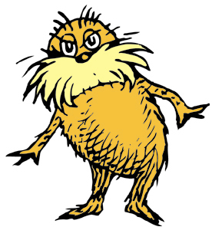  By Charlie and Karan  Ew? What’s this? That’s what we said while picking up garbage on Earth Day. Earth Day is about helping the environment. At our Earth Day assembly, we read The Lorax with Room 15. We practised hours, days and weeks until the big day came! Although we were a huge group to fit in the front of the gym, it was amazing! We had two rows, separated by pages read. Everyone had 1 or 2 parts to read. The Lorax had to do with Earth Day because it is about taking care of trees. We had tons of fun reading The Lorax and picking up garbage!  Titanic Movie Review  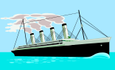  By Iman, Hanna and Natalie  The movie Titanic is a love story and a drama. It is aboutr a 1st class passenger named Rose who meets a 3rd class passenger named Jack. Jack was lucky because he won his tickets to the Starline R.M.S. Titanic through gambling. Rose’s evil fiancé made Rose want to end her life and this brought Rose and Jack together. Jack convinces Rose to live life to the fullest during their fun times on the Titanic. But then the Titanic hits an iceberg. No one panics at first because the Titanic is unsinkable…or so they thought. Watch this movie to find out what happens – who survives and whose life goes to the deep.    Chimpanzee Movie Trip  By Sasha, Laura Beth and Priscilla  Emotion! Joy! Surprise! This movie has it all! On April 24th, all of the juniors from Westvale went to a private showing of the Disney Movie, “Chimpanzee” at Empire Theatres. “Chimpanzee” is about a 3-month old chimpanzee named Oscar who was abandoned after his mother was killed by a cheetah. Then an amazing thing happened – Freddy, the leader of the troop, decided to adopt Oscar. This meant the highest rank in the troop was helping the lowest. This movie was really good. Maybe you can see it with your family. |  | Harry Endrulat  By Evi, Iman and Armaan  On April 23rd, an author named Harry Endrulat came to our school. He gave us good tips on how to become an author. Some of the tips he gave us were, you can write stories based on TV shows, non-fiction and imagination. Did you know that Harry Endrulat was inspired to be an author by making up stories for his kids? Most of the stories he wrote were Max and Ruby books (26 in total!). He also wrote a very popular Silver Birch book called A Bear in War. A Bear in War is a non-fiction book. Harry discovered the story for the book by reading the newspaper. The teddy bear in the story can be found in the War Museum in Ottawa. Harry Endrulat also visited our school at night and three lucky kids got to read A Bear in War aloud. Harry Endrulat is an outstanding author.    Silver Birch Voting  By Katie, Gabriel, Mark and Keenan  This month, Silver Birch readers got to vote for their favourite book. You could only vote if you had read five books from one of the categories. There were 3 categories: Express, Fiction and Non-fiction. There were 10 books in each category. The winner of the Express category was The Last Loon. The Fiction winner was Undergrounders and the Non-fiction winner was 50 Poisonous Questions. Everybody in our class participated in Silver Birch. All the books were very exciting and we are looking forward to voting again next year!  Beards for Boulders  By Brenna, Cassidy and Jessie  At the Earth Day assembly we raised enough money to shave Mr. Matsuo and Mr. Masurkevitch’s beards. Mr. Masurkevitch also shaved his head! We raised $600 – enough for 4 boulders! The teachers picked names to shave the beards – and unfortunately, only boys got picked! Beards for Boulders was a very fun fundraiser.  Mirror Mirror    By Nicole and Arlinda  “Mirror, mirror on the wall, who’s the fairest of them all?” The movie “Mirror Mirror” is about an evil queen (Julia Roberts), Snow White (Lily Collins), the prince (Armie Hammer), Brighton (Nathan Lane) and the 7 dwarves. This film is based on one of the most beloved fables of all times. The movie is about a queen who hates her stepdaughter. The queen hates her so much that she orders someone to kill her! Snow White must train to fight her enemy (the queen). Who will train her? Will she succeed or will she be killed? Find out by watching this great movie.  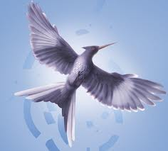  MockingJay Book Review  By Ephraim  Boom! The pods from the Capital explode as Rebels walk by. They have to go underground! But what’s this? Mutant lizards come and have a go! Finnick! He’s the winner of one of the Hunger Games and just married! Now what? Katniss fights for him. Read this exciting final book in the Hunger Game series to find out what happens next!    Hats for Habitat for Humanity!  By Sasha, Laura Beth and Priscilla  On April 11th, our school was allowed to wear hats to support Habitat for Humanity. If you were wondering what this means – well, if you brought in a dollar or more to wear a hat, then the money was donated to Habitat for Humanity. This event was organized by the WE group. We raised $200 for Habitat for Humanity – that’s a lot! It was a blast wearing a hat and raising money!    Teacher’s Note  Congratulations student writers on the completion of our April newsletter! Writing for the newsletter continues to be on a voluntary basis, though students are encouraged to sign up and write an article at least once every other month. Please remember that the newsletter is also available electronically on our website – http://arscott.weebly.com.

